Unidad 1:

# Planificación de interfaces gráficas

1 Ejercicios IPO:

1. Enumero diferentes tipos de interfaces que conozcas. Escribe un ejemplo de cada una:.

Interfaz gráfica como la de usuario.

Interfaz visual como la de los dispositivos móviles.

Interfaz de texto como el teclado o la pantalla de la tablet

Interfaz de voz como Siri, Alexa, Google asistant, Cortana, Bixbi, Hola Mercedes…

Interfaz natural como la kinética de los videojuegos, las capturas de pantalla con gestos…

Interfaz cerebro-ordenador como las que se usan para las prótesis

1. Reading: Augmented Reality UI

Autocap.

Se utiliza en interfaces como las que usan las apps móviles para ponerte filtros, gafas o maquillaje.

1. Zero UI

La interfaz cero es aquella que nos permite comunicarnos con los dispositivos sin necesidad de usar las pantallas como los asistentes de voz

2 Design principles & elements

|  |  |  |
| --- | --- | --- |
|  |  |  |
| Asimétrico | Simétrico | Simétrico |
|  |  |  |
| Asimétrico | Simétrico | Radial |



1 How does the reader know what is important? The reader knows which is the most important because it is highlighted by the contrast of colours.

2 How does the reader know what to look at first? The reader knows what to look for first by the size of the letters and by the highlighting of some words

3 What keeps the reader focused? it is maintained by the ease of viewing the letters and images

4 What draws readers in and keeps their attention? he is attracted by large letters and images

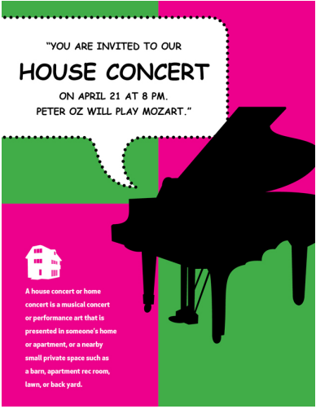

1 How does the reader know what is important? The piano because it is with contrast.

2 How does the reader know what to look first? You know it because it is in bigger letters

3 What keeps the reader focused? the contrast keeps it that way to be able to read better

4 What draws readers in and keeps their attention? It is kept there by the contrast of colours and how striking they are

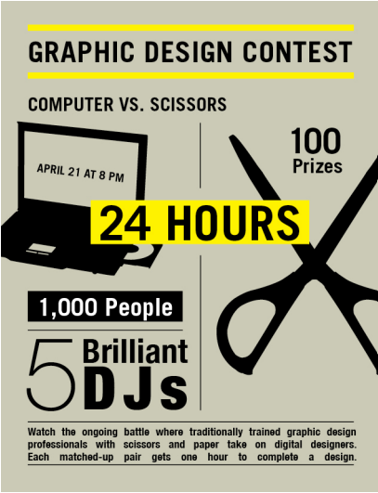

1 How does the reader know what is important? You know it because it is highlighted

2 How does the reader know what to look first? Knows what to read first because it has bigger letters and is highlighted

3 What keeps the reader focused? the contrast of colours keeps you attentive

4 What draws readers in and keeps their attention? He is attracted to the images and the contrast of these with the background

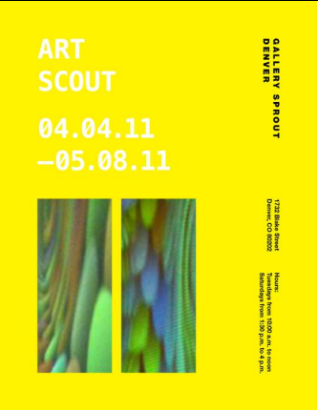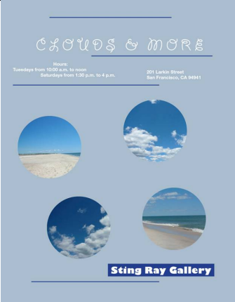

In the first image I think that the alignment is effective since when we see things in more order, it is easier for us to read or look at them.

In the second image I find the alignment adequate because it generates a feeling of order.

In the third image I think the alignment is appropriate as the information in the image is more orderly and calmer for the reader.

|  |  |
| --- | --- |
|  |  |
| Contraste | Movimiento |
|  |  |
| Énfasis | Movimiento |
|  |  |
| Repetición | Énfasis |
|  |  |
| Alineación | Énfasis |

|  |  |
| --- | --- |
|  |  |
| Color | Espacio |
|  |  |
| Valor | Tamaño |
|  |  |
| Forma | Línea |
|  | Textura |